HTML & CSS - Website Task ‘The Choc Shop



Contents

**LOGO.**

Canva

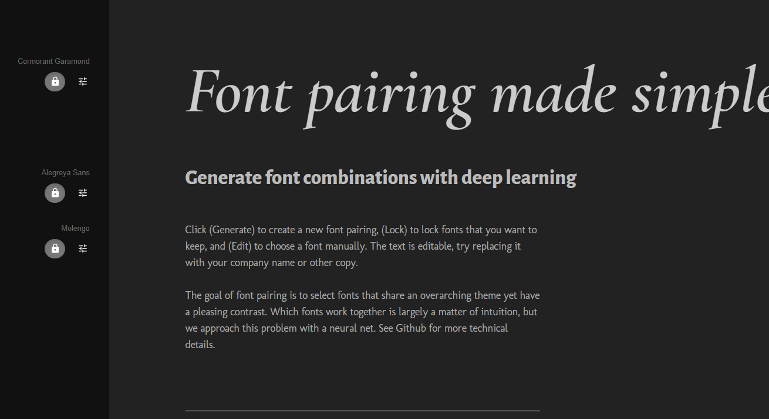

Font Looks relatively posh

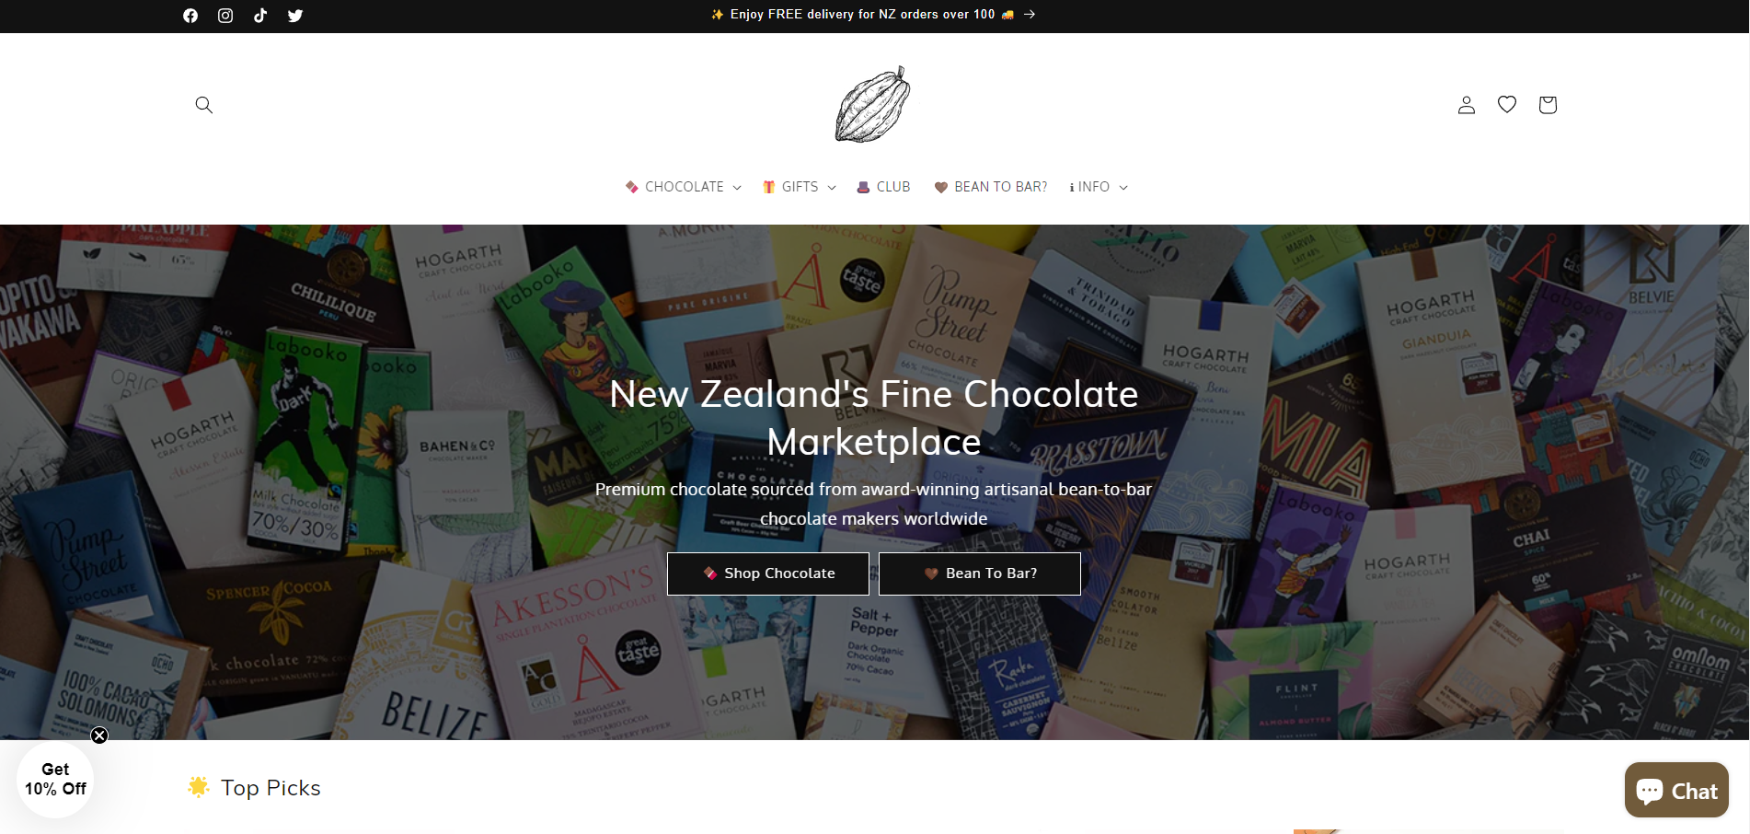

Website 1

Simple

Straight to the point

Website 2

Very tasty lookin chocolate at the front

User friendly bar

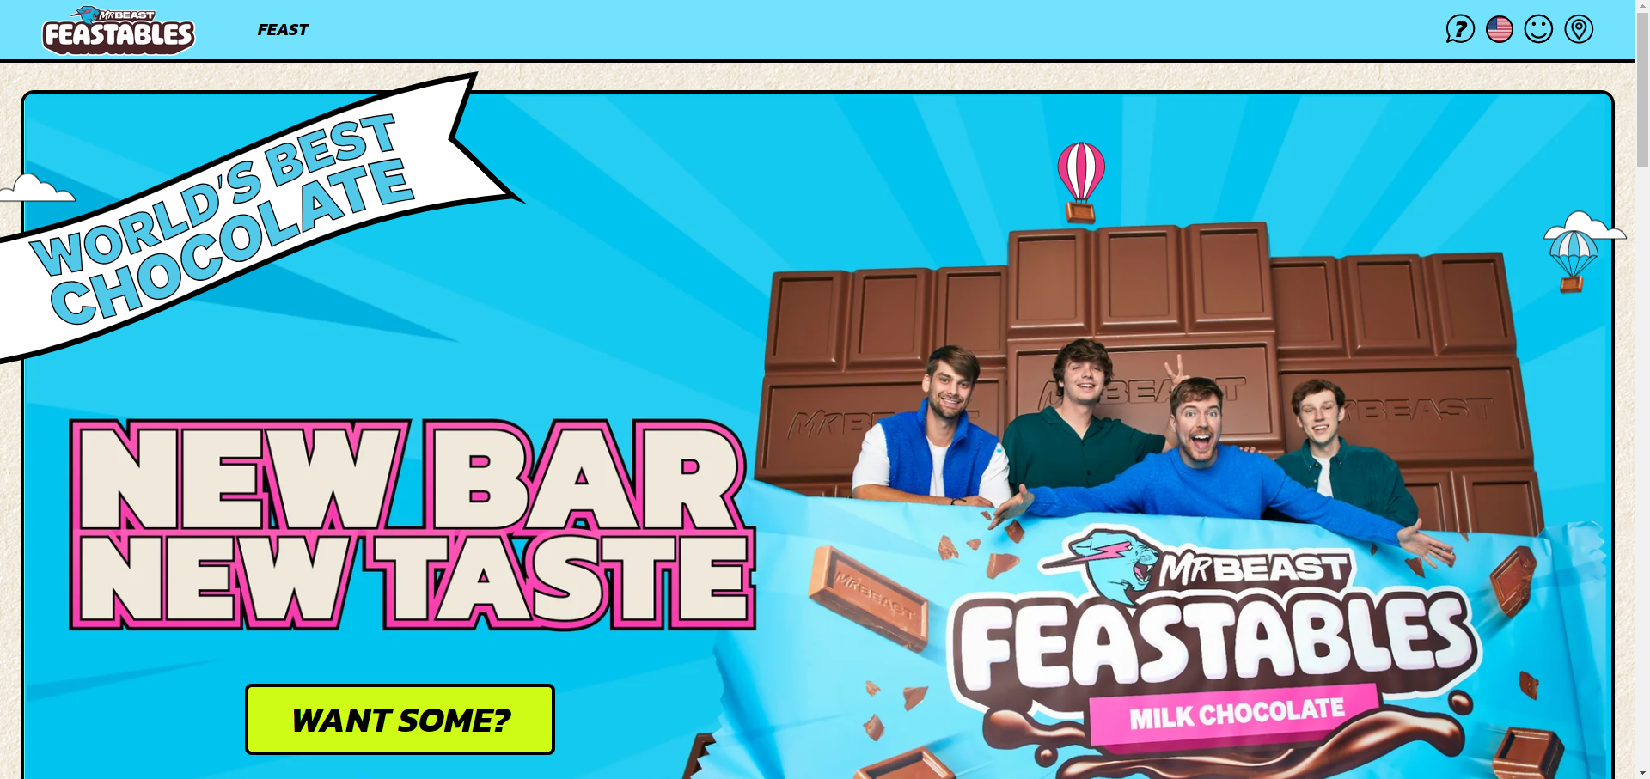

Website 3

Cleary words best chocolate

Simple /easy to use

Shows that theres a new bar